**Chapter 5 Skills Summary - Relations and Functions**

1. **Skill: Determine the domain and range of a function**

Strategy: Domain is the set of values for the independent variable and the range is the set of values for the dependent variable.

**Examples**:

1. Using the graph to answer the following:

a) Determine the independent and dependent variables

b) Write domain and range in set notation

c) Write domain and range in interval notation

d) Does this function represent discrete or continuous data?

e) If the points were not connected, write the domain and range.



2. Make an arrow diagram using the following table

b) What other ways could we represent this? Complete each.

**3 . Skill: Determine the rate of change of the graph of a linear function.**

Strategy: rate of change = change in dependent variable

change in independent variable

Example:

What is **the rate of change** for the following graph? What is

another word for rate of change?

**4. Skill: Determine the intercepts of the graph of a linear function.**

Strategy: The x-intercept is the value of  when  or  is 0. The y-intercept if the value of  when  is 0. 

Example: Using the following graph state the x and y intercepts and explain what each represents.



[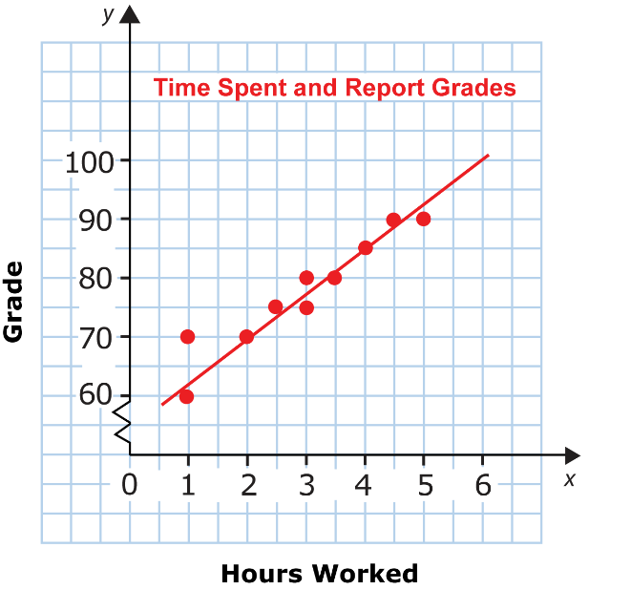](http://www.google.ca/url?sa=i&rct=j&q=&esrc=s&frm=1&source=images&cd=&cad=rja&uact=8&docid=9SzZttNwpOVaDM&tbnid=CBa_bBQXfwndZM:&ved=0CAUQjRw&url=http://www.ck12.org/user:amhhdGVydEB5c3NjaG9vbHMub3Jn/book/McKinney-Integrated-Math/r1/section/4.8/&ei=xK-MU8OnKIiYyATa9ICQAQ&bvm=bv.67720277,d.aWw&psig=AFQjCNHkkV_6m2ocKrahujEZwSiZ_EbImw&ust=1401815325921943)

1. **Skill: The line of best fit.**

Strategy: Graph data on a scatter plot and draw a straight line through or close to as many points as possible (use a ruler).

Try to have the same number of points above and below the line.

Example: Use the following graph to predict how many hours students would need to study to receive a grade of 100.

**6. Skill: Using linear regression to find the correlation coefficient of a set of data.**

Strategy: r is a measure of how well the line fits the data. When r =1, the fit is perfect. The closer r is to 1 or -1, the closer the line fits the data.

Example:

You used the TI-84 to input a table of values and then performed a linear regression on the data. Use the information on the screen below to answer the following:

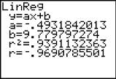

1. Write the linear equation for the line of best fit for the data in slope-intercept form.
2. Give the value of the correlation coefficient. How well does the line fit the data? Explain how you know.

**7. Skill: Finding the distance and midpoint of a line segment.**

Strategy: 1. Use the following formula to find the distance 

1. Use the following formula for midpoint 

Example: The endpoints of the diameter of a circle are E(6, 6) and F(–2, –4).

1. Determine the coordinates of the centre of the circle.
2. Determine the length of the radius.

Pg. 459-460

Ques. 10-16