These are problem solving questions given by Straight Regional Centre for Education.
An answer key (done out) will be provided but answers to questions are provided at the end of this sheet as well.

Chapter 1 Measurement:
- All of the water from a full cylindrical tank is drained into a rectangular aquarium. The cylinder has a height of 50 cm and a diameter of 30 cm. How deep is the water in the aquarium, if it has a rectangular base measuring 40 cm by 20 cm? (round answer to the nearest centimetre)
(Ans: 44 cm high)

- A pail of ice cream is cylindrical, with diameter 10 in. and height 14in. An ice cream scoop makes a sphere of ice cream with diameter 2 in. How many full scoops of ice cream can be made from this pail? (Ans: 262 scoops)

- If the lateral area of this shape is 54 in² what is the value of x? (Ans: 7 in)
Height 3 in.
Width 2 in
Length x
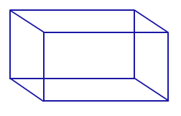

- A calf is tied with a 10 m rope outside the corner of a barn that is 5 m by 6 m. Draw a diagram to help you determine the area that the calf can graze. Give your answer to the nearest tenth of a square foot.

- A rectangular garden is 70 m wide and 150 m long. A large cylindrical tank with diameter 11.2 m and height 2 m is to be buried in the garden, to create a round swimming pool. All of the dirt removed to create the hole for the tank is spread evenly over the garden. By what height is the garden raised? Round answer to the nearest hundredth of a metre.

- Traditional Chinese units of length have varied over time. However in 1984 these units were standardized.
$$1 chi= \frac{1}{3} meter$$
$$1 lin=\frac{1}{2 } kilometer$$

What is the equivalent of each of the following?

- 3 lin in feet, to the nearest tenth of a foot.

- 5 chi in inches, to the nearest tenth of an inch.

- In the diagram below, PQRS is the square base of a solid right pyramid with vertex V. The sides of the square are 8 cm, and the height VG is 12 cm. M is the midpoint of [QR].
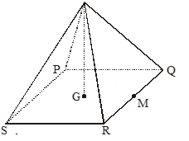
Diagram not to scale
V
- Calculate the length of [VM].
Round to the nearest tenth

(b) Find…
(i) The total surface area of the pyramid;
Round to the nearest tenth

(ii) The angle between the face VQR and the base of the pyramid.
Round to the nearest tenth

Chapter 2 Trigonometry
- The base of a right rectangular prism is square. Its height is three times one of the sides of the base.
- If the overall volume is 375 in³, what is the length of the longest diagonal distance within the prism?

- What is the measure of the angle of elevation of the diagonal found in a). ?

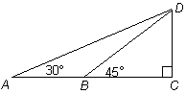
- A person observes that from point A, the angle of elevation to the top of a cliff at D is 30°. The distance from A to D is 160 m. Another person at point B, notes that the angle of elevation to the top of the cliff is 45°. Determine the distance between the two observers. Show the steps of your solution. Round to two decimal places

