These are problem solving questions given by Straight Regional Centre for Education.
An answer key (done out) will be provided but answers to questions are provided at the end of this sheet as well.

Chapter 3 Factors and Products
- Mr. Particular is very particular about his vegetable garden. The dimensions of his rectangular garden are 51 ft. wide by 68 ft. long. This year, Mr. Particular wants to divide his garden into square sections.
  - What are the dimensions of the largest possible square that Mr. Particular could use to divide up his garden? (17 ft x 17 ft)

  - Mr. Particular wants to plant a different type of vegetable in each square. How many different types of vegetables can Mr. Particular plant? (12 plants – need a drawing)

- Ms. Smith has 18 students in her grade ten math class. At the start of the school year, Ms. Smith wants to purchase extra supplies for each student. At Bulk Hut, pencils can be purchased in packs of 48. Erasers are available in packs of 32. Scribblers come in packs of 24. (6 packs of pencils, 9 packs erasers, 12 packs scribblers)
  - What is the least number of packages of pencils, erasers and scribblers Ms. Smith can purchase so that she buys the same number of each item? (6 packs of pencils, 9 packs erasers, 12 packs scribblers)
  - If Ms. Smith divides the supplies equally among the students in her class, how many pencils, erasers and scribblers will each student receive? (16 of each item per student)
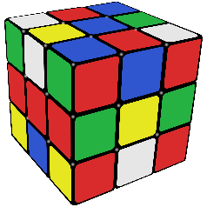
- The surface area of a Rubik’s cube is $30\frac{3}{8}$ in².
  - Determine the volume of a Rubik’s cube to the nearest tenth of a cubic inch. (11.4 in³)
b. Determine the volume of one of the smaller blocks in Rubik’s cube to the nearest tenth of a cubic inch. (0.4 in³)

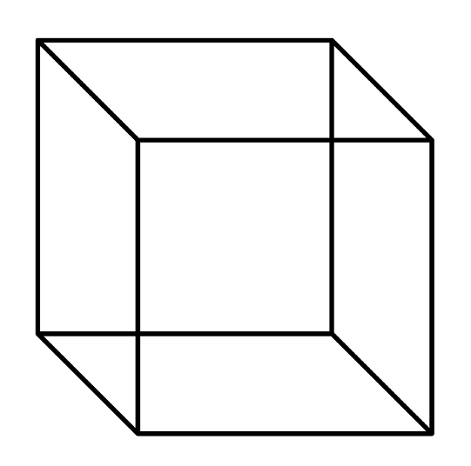
- A cube-shaped glass vase has a capacity of 1728 cm³.

  - Use prime factorization to determine the edge length of the vase.
(12 cm)

  - Determine the surface area of the lateral faces of the vase to the nearest cm². (576 cm²)

- A storage silo has a cylindrical top with height h and radius r, and a cone-shaped bottom with a slant height s.
r
h
s
  - Write an expression for a surface area of the silo. Factor the expression.
(Ans: πr (s + r + 2h) )

  - Determine the surface area of the silo when the radius is 4 m, the height is 11 m, and the slant height of the cone is 10 m. Verify your answer by finding it using the factored and unfactored expression. Round to two decimal places.
(452.39 m²)

  - Write an expression for the volume of the silo. Factor the expression.
(V = πr² (h_{cyl} + 1/3 h_{cone}) )

  - Determine the volume of the silo using the same dimensions from part b. Verify your answer by finding it using the factored and unfactored expression. Round to 2 decimal places.
(706.48 m³)

- Cameron has two x² tiles and eight ones tiles.
  - Using the tiles he already has, how many x tiles could Cameron use to complete a rectangular model? Draw a diagram of the rectangular model.
(Possible answers in the same order as b: 10 x tiles
8 x tiles
  - Write a multiplication sentence that represents the rectangular model.
(same order as a: 2x² + 10x + 8 = (2x + 8)(x + 1)
2x² + 8x + 8 = (2x + 4)(x + 2)

  - How many different positive integers can you find to replace $∎$ so that the trinomial can be factored?
$$2x^{2}+∎x+8$$
(see answer above – same solution!!! There are 2 different ways to fill this in. You can have 8x or 10x)

- Write a simplified expression for area of the shaded region.
2x + 6
3x – 12
x + 8
2x + 1

(5x² -29/2 x – 76)

- The outside of a picture frame has the dimensions 12 inches by 18 inches. The width of the frame surrounding the picture inside has a value y.

  - Write a simplified expression for the area of the picture (shaded). (A = 4y² -60y + 216)
y
y
12 in.
18 in.

  - If the value of y is 1.25 inches, determine the area of the picture to the nearest hundredth. (147.25 in²)

- A cement cube has an edge length of x + 3. A smaller cube with an edge an edge length of 2x is removed from the cement cube. Write a simplified expression for the volume that remains.
(V = -7x³ +9x² +27x +27)
x + 3
2x
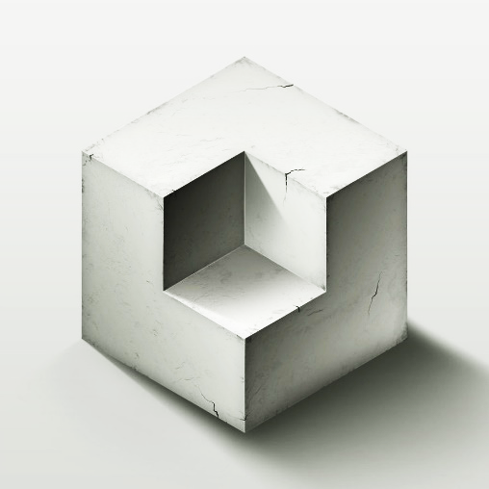

Chapter 4 Roots and Powers
- Choose and verify values of $n$ and $x$ so that $\sqrt[n]{x}$ is: (There are multiple different answers)
  - A whole number b. A negative integer
  - A rational number d. An irrational number
- Decide if each of the following are rational or irrational for perimeter and for area.
  - Area = 25 m² The area is _________________________ and the perimeter is ____________________
  - Area = 20 in² The area is _________________________ and the perimeter is ____________________
  - Area = π The area is _________________________ and the perimeter is ____________________
- A cube has a volume of 405 cm³.
  - Use prime factorization to determine the edge length of the cube. Write your answer as a simplified radical. ($3\sqrt[3]{15}cm$)

  - Determine the surface area of one the cube’s faces. (54)(15^{2/3})cm²

- The largest square in the diagram has a side length of 6 cm. Calculate the area and perimeter of the shaded square. Leave in simplified radical form for perimeter.
A = 18cm² P = 12$√2$cm

- Determine the exact value of the following expression: ${\left(\frac{25}{36}\right)}^{\frac{1}{2}}+\sqrt{\frac{49}{16}}+\sqrt[3]{343}+{\left(2^{3}\right)}^{\frac{2}{3}}$
(Ans: 163/12)

- Simplify the following expression using only positive exponents: ${\left(\frac{{\left(144a^{6}{a^{4}b}^{10}\right)}^{\frac{1}{2}}}{{\left(2a^{2}b^{-3}\right)}^{2}}\right)}^{-3}$
(Ans: 1/(3a³b²⁷)

- The two legs of a right triangle have lengths of 4x² and 2x³. Write an expression for the length of the hypotenuse. Hint: Factor! (c = 2x² $√(x2+4)$
2x³
4x²

